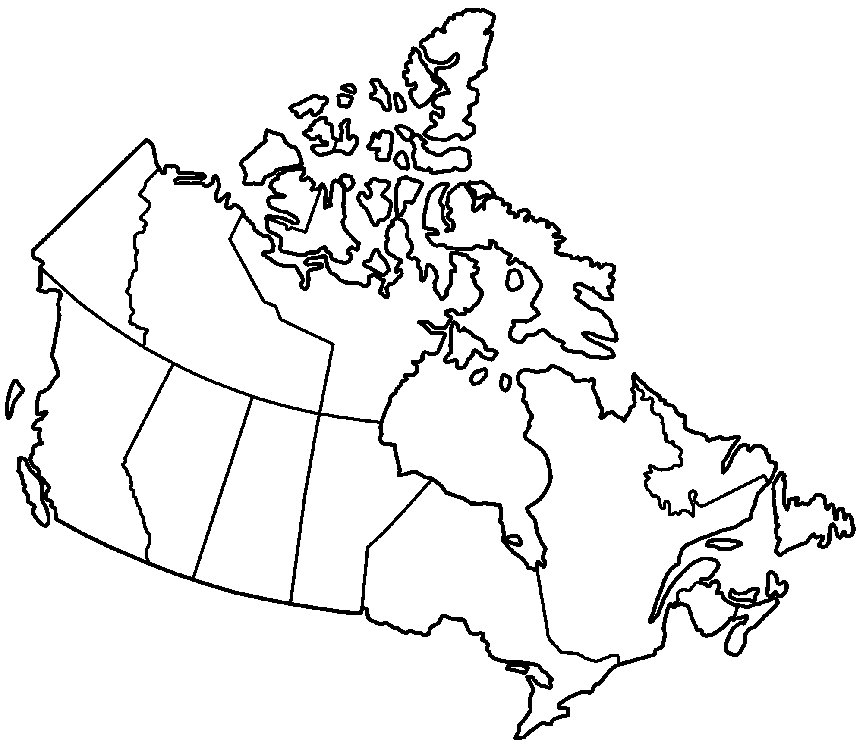
AA
B
C
D
E
F
G
H
I
J
K
L
M
N
O
P
Q

